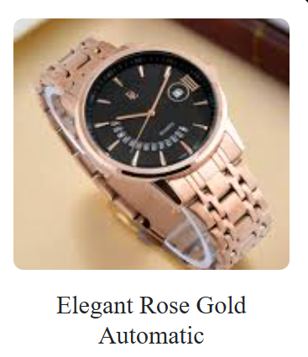

**Product Name:** Elegant Rose Gold Automatic Watch

**Description:**  
A sophisticated timepiece featuring a rose gold finish and automatic movement, combining elegance with functionality.

**Specifications:**

* **Movement:** Automatic
* **Case Material:** Stainless Steel with Rose Gold Plating
* **Dial Color:** Rose Gold
* **Strap Material:** Leather or Stainless Steel
* **Water Resistance:** Up to 50 meters
* **Functions:** Date display, 24-hour subdial, Moon Phase (varies by model)
* **Glass:** Sapphire or Mineral Crystal
* **Case Size:** Ranges from 36mm to 45mm

**Price:** Rs. 27,900